Validation for Caffeine Investigation 2012

1. For this investigation what is the independent variable?( 1mark)

Age

1. What is the dependent variable? (1 mark)

Distance that people could reach past their toes.

Or flexibility of lower back and legs

1. State a hypothesis for this investigation. ( 2 marks)

Younger people will be able to reach further past their toes. (both the independent and dependent variable must be mentioned. 1 mark for each)

1. Here are the results of this investigation.

Complete the table below

|  |  |  |
| --- | --- | --- |
| Name | Age  (years) | Flexibility  (cm) |
| John | 19 | 10 |
| Jim | 17 | 2 |
| Jenny | 18 | 7 |
| Jack | 18 | 12 |
| Annie | 19 | 9 |
| Total | | **40** |
| Average | | **8** |
| Craig | 41 | 0 |
| Sandy | 44 | 2 |
| Lam | 43 | 14 |
| Jasper | 41 | 4 |
| Roddy | 47 | 4 |
| Total | | **24** |
| Average | | **4.8** |

(1 Mark)

Must get all correct for mark.

1. Draw a suitable graph of the results in the previous table.
2. marks)

All student start with 5 marks. Then take one mark off for each of the following done wrong.

Must be bar graph

Age on horizontal axis. Distance reached past toes on verticle.

Both axis labelled.

Units of measure given as (cm) on vertical.

Heading must include dependent and independent variable.

Must be accurate.

1. How could the results have been made more accurate? (1 mark)

State one of the following.

Larger sample size(more people tested)

Repeating the experiment.

Multiple trials

1. What is your conclusion for the experiment above?

The hypothesis was supported by the results, younger people were able to reach further past their toes.

(1 mark)

1. Using the graph you drew, would it be possible to do accurate extrapolation for people of other age groups? Explain why.

NO.(1 mark)

You need a line graph (or histogram) to extrapolate.(1 mark)

(2 marks)

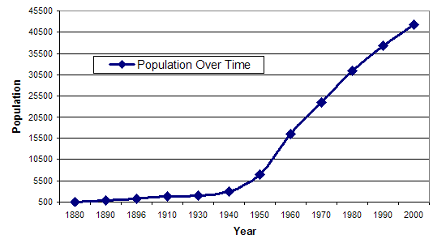

1. What will the population be in 2010?

Accept anything between 4650 and 4800 (1 mark)

1. Was your answer to question 3a an example of extrapolation or interpolation? Give a reason for your choice.

Extrapolation(1 mark). This is because the measurement was taken beyond the range of collected data (1 mark).

1. What was the population in 1965?

20500 with about 200 on either side accepted. (1 marks)

1. Was your answer to question 3c an example of extrapolation or interpolation? Give a reason for your choice.

Interpolation (1mark). This is because it the measurement was taken within the range of collected data(1 mark).

1. Which was more likely to be correct, your answer to question 3a or 3c? Give a reason for your answer.

Answer D(or they can say interpolation)(1 mark) because answer a was a prediction beyond the range of collected data(1mark)

/22 marks